**Premiere Pro**

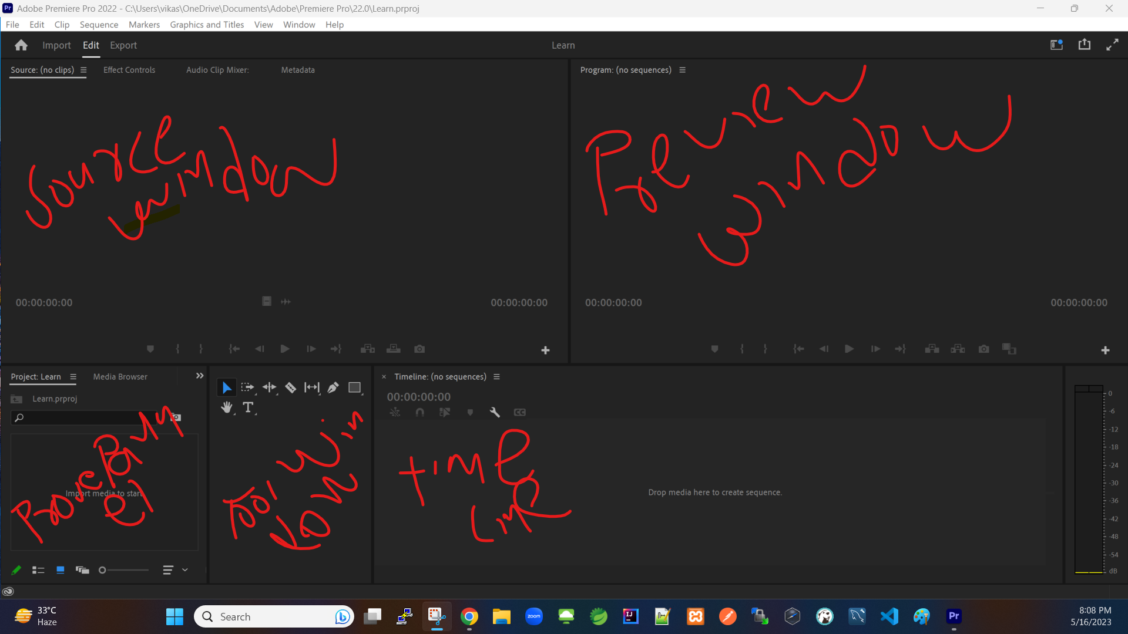

2. Project Setting:

a. Renderer – keep Mercury Playback Engine GPU Acceleration – it will use GPU while renderer

b.